**DAILY ONLINE ACTIVITIES SUMMARY**

|  |  |  |  |  |  |  |  |
| --- | --- | --- | --- | --- | --- | --- | --- |
| **Date:** | **26/05/2020** | | | | **Name:** | **Amrutha g** | |
| **Sem & Sec** | **4TH&A** | | | | **USN:** | **4AL18CS006** | |
| **Online Test Summary** | | | | | | | |
| **Subject** | | **DESIGN AND ANALYSIS OF ALGORITHM** | | | | | |
| **Max. Marks** | | **30** | | **Score** | | **23** | |
| **Certification Course Summary** | | | | | | | |
| **Course** | **Introduction to digital marketing** | | | | | | |
| **Certificate Provider** | | | **Great learning academy** | **Duration** | | | **2.5 hours** |
| **Coding Challenges** | | | | | | | |
| **Problem Statement:1:Write a program in c to print all permutations of a given string using array**  **Problem Statement 2:** . **Given an array A of size N where the array elements contain values from 1 to N with duplicates, the task is to find total number of subarrays which start and end with the same element.** | | | | | | | |
| **Status: executed** | | | | | | | |
| **Uploaded the report in GitHub** | | | | **YES** | | | |
| **If yes Repository name** | | | | **https://github.com/AMRUTHAGANESH/lockdown-codings** | | | |
| **Uploaded the report in slack** | | | | **YES** | | | |

Online Test Summary:

**DESIGN AND ANALYSIS OF ALGORITHM**

**18CS42 the test was from 2nd module about divide and conquer. There are 30 questions and the duration 30 minutes.**

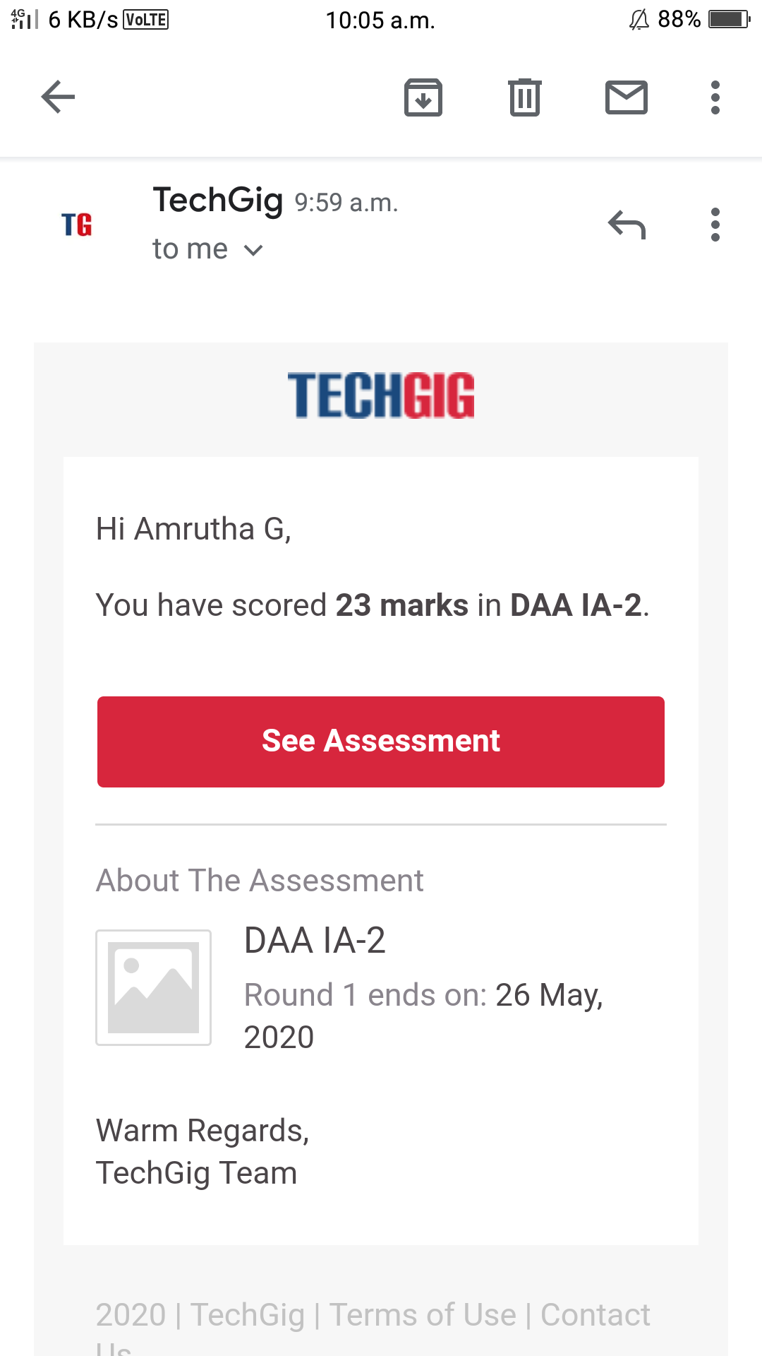

Online Certification course:

Today in great learning app I learnt about purpose of using Facebook as marketing channel and also learnt facebook interface type of audience



2nd one:

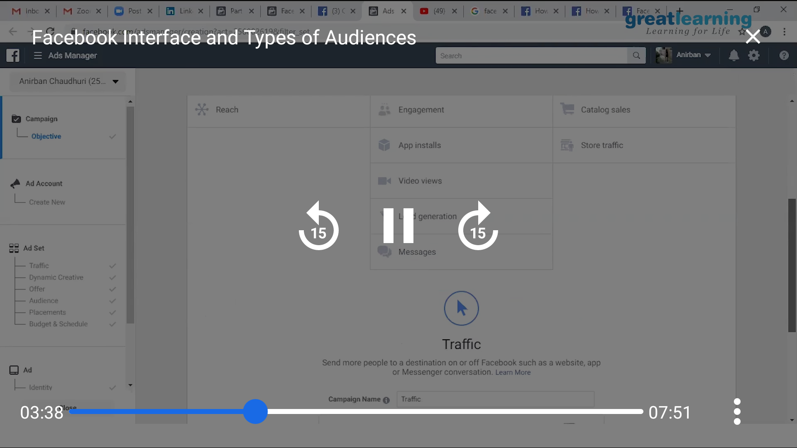

This is the snapshot of today's course

Online Coding summary:

**1.Write a program in c to print all permutations of a given string using array**

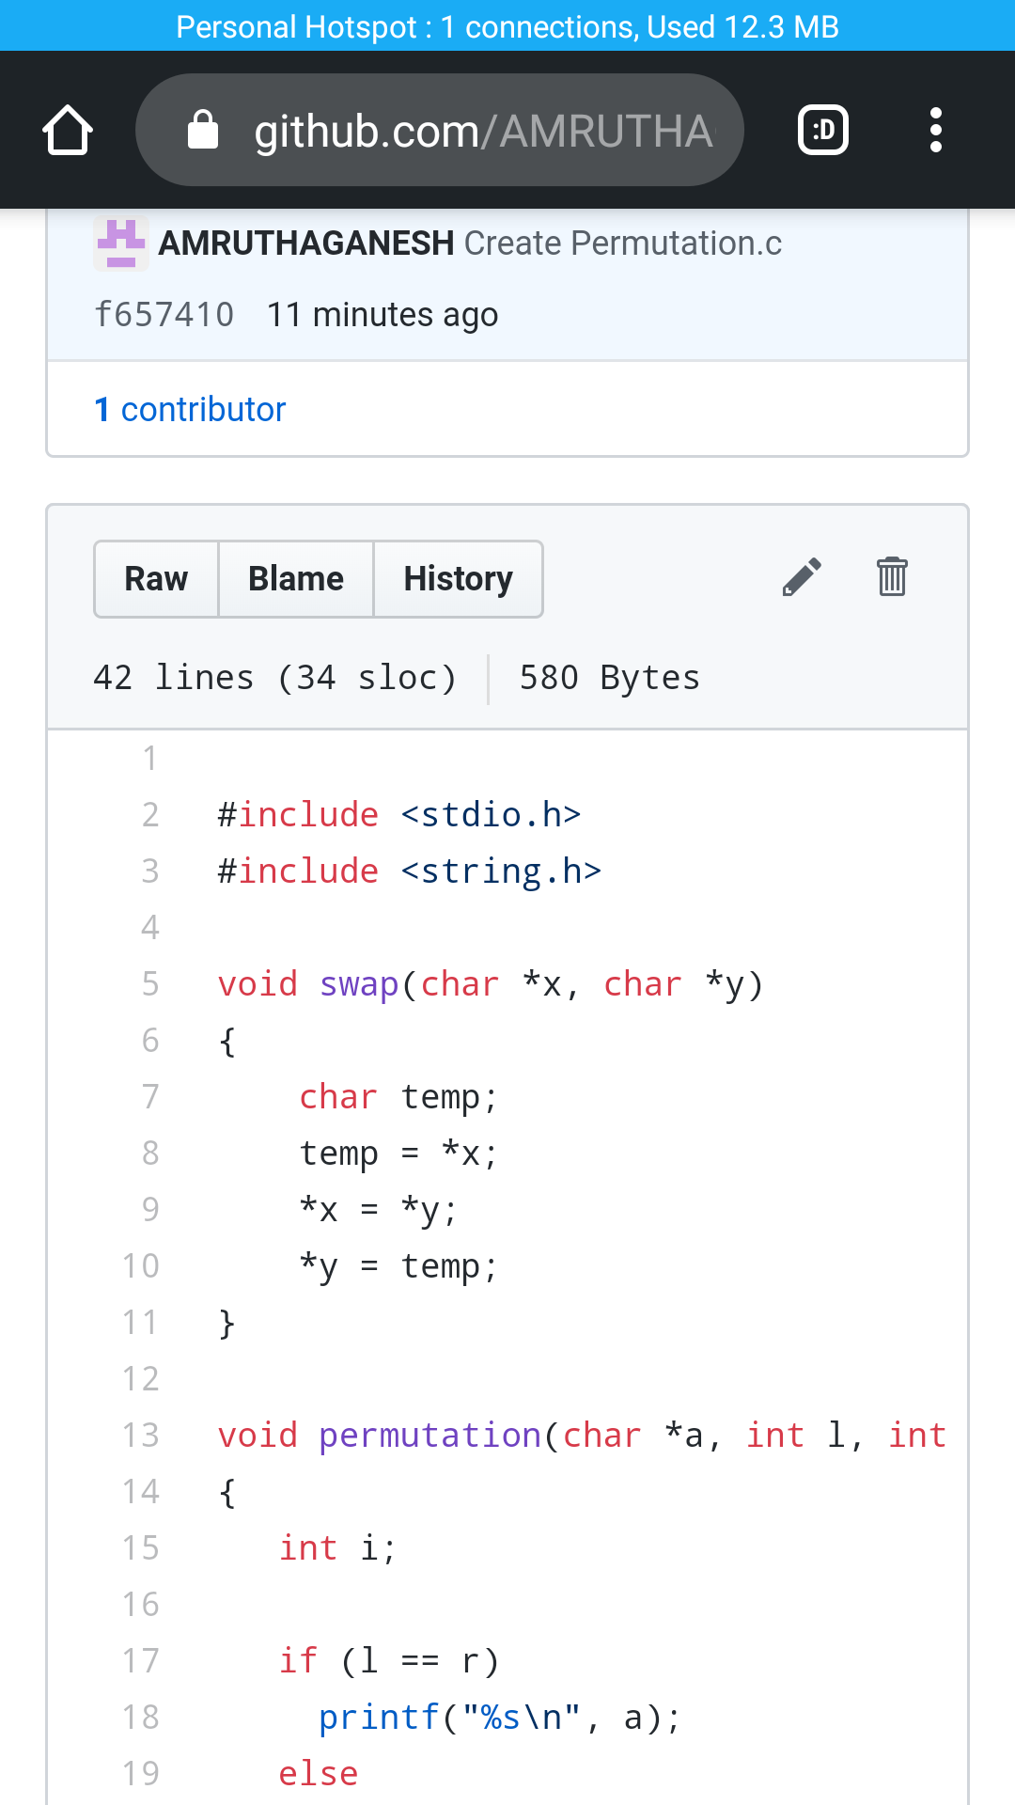

**2. Given an array A of size N where the array elements contain values from 1 to N with duplicates, the task is to find total number of subarrays which start and end with the same element.**

